Configuring Axis Camera Software for 975 on Mobile Device

To install the Axis Camera software, download the Axis Camera Station software from the app store. Skip to page 3.
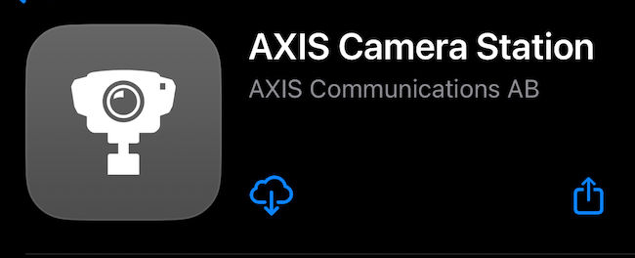

If you already have the Axis software on your phone connected to MSW975DVR1, you need to remove it from the application and re-configure the server name.

To remove the application, click on MSW975DVR1 in the top left corner.
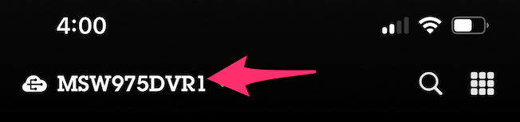

Click All Systems
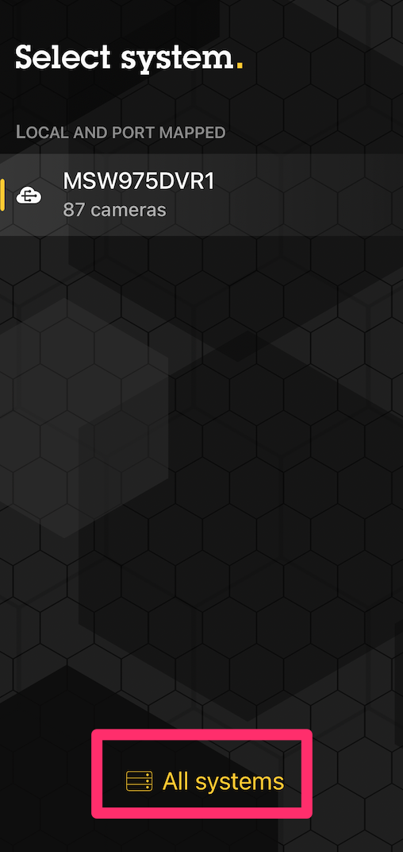
Click the i to the right of MSW975DVR1.
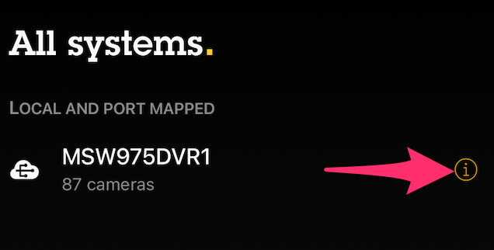

Click Remove System
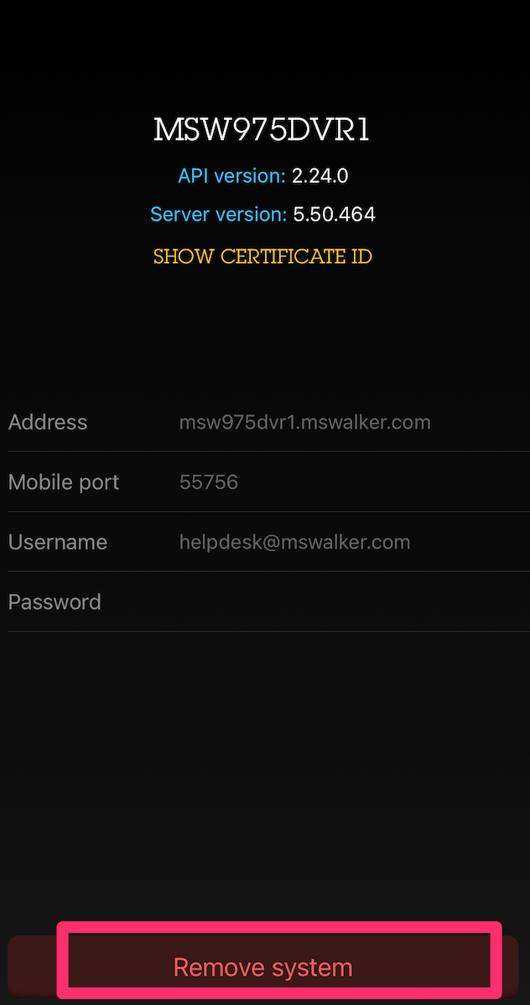

Click Add System
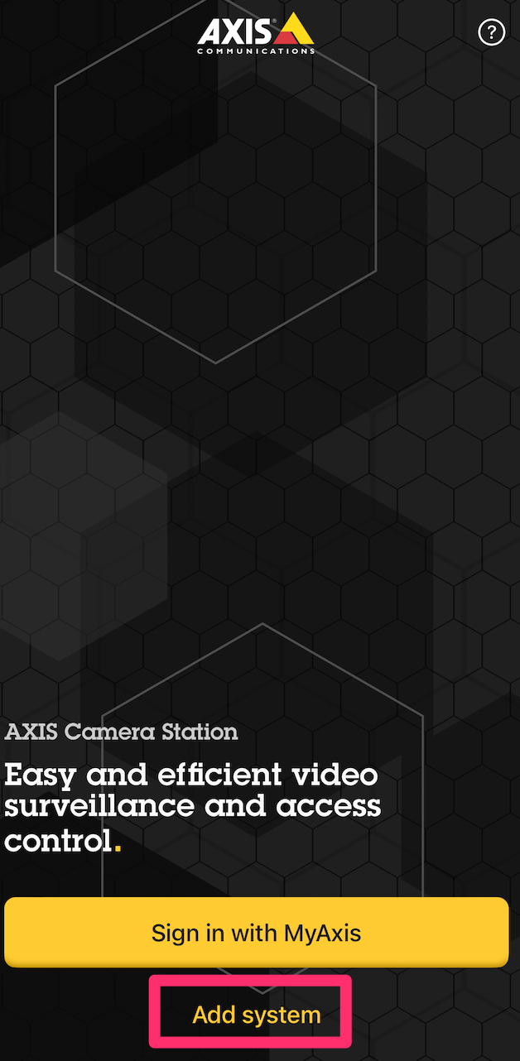

Click Add Manually
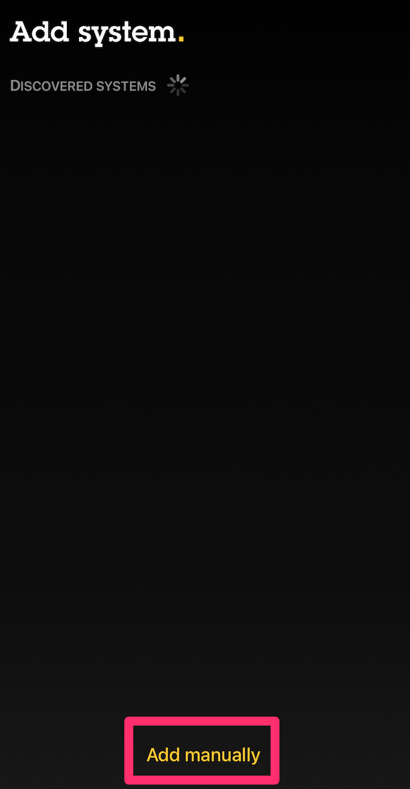
Enter the following information:
Address: msw975dvr1.mswalker.com
Username: firstinitiallastname@mswalker.com
Password: Same as your computer/email
Click Log in
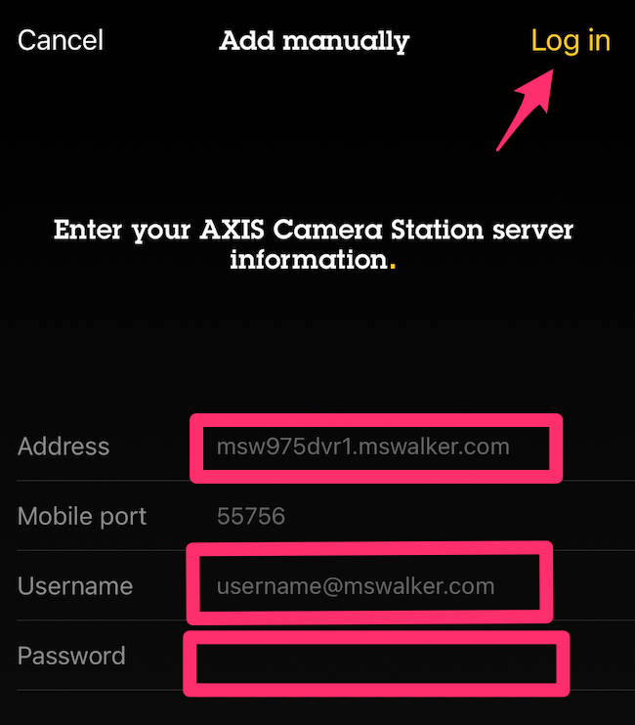

In the box that pops up, click connect.
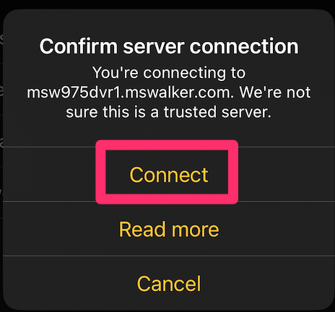

You will now be connected to the DVR system. The application will work both inside and outside of the office.

